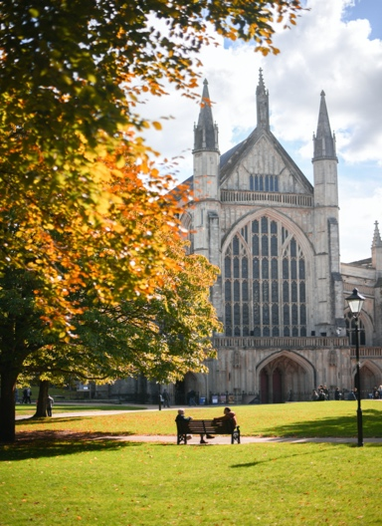
HAMPSHIRE AND THE ISLANDS HISTORIC CHURCHES TRUST (charity no 1181370)
AGM, TALK & DRINKS
Wednesday 23rd June 2026 at 7.00 pm in Winchester Cathedral - by kind permission of the Dean
7pm AGM and Church Awards
- Welcome and Apologies
- Minutes of the AGM on 19th May 2025
- Chair’s Report – Dr Tim Goulder
- Treasurer’s Report – John Steel
- Presentation of Awards – Nigel Atkinson, Esq. HM Lord-Lieutenant of Hampshire
7.30pm Some of the Churches HIHCT has been able to help – by the grants committee
7.45pm “Buildings as Mission” a talk by The Very Revd Chris Palmer, Dean of Winchester
8.30pm Drinks and Nibbles in the Cathedral North Transept
9.00pm Finish
Please complete the reply slip below by Monday 22nd June 2026 and send it to: Keith Miller 36 Swanwick Lane, Swanwick, Southampton. SO31 7HF or email hihctmembership@outlook.com --------------------------------------------------------------------------------------------------------------------------------------------------- AGM on Wednesday 23rd June 2026
Name(s):-............................................................................................................................................................... Address:- ..................................................................................................................................
Tel:- .................................. Email:- ........................................................................................
I would like to attend the AGM and my party will consist of ______________ people
I require a reserved disabled parking space for ................................................... [Car Registration]

